IMPORTANT - NOTICE OF ROAD CLOSURE
Our ref: HM5132422078
Dear Customer,
We are writing to inform you of a road closure in the area on the 5th December 2023. This will be for one working day so that we can complete maintenance on the overhead network.
Please see the map below to advise where the road closure will be in place. We understand that this part of the road is extremely inconvenient for a road closure. We will be working as quickly and safely as possible to get this road re-opened as soon as possible.
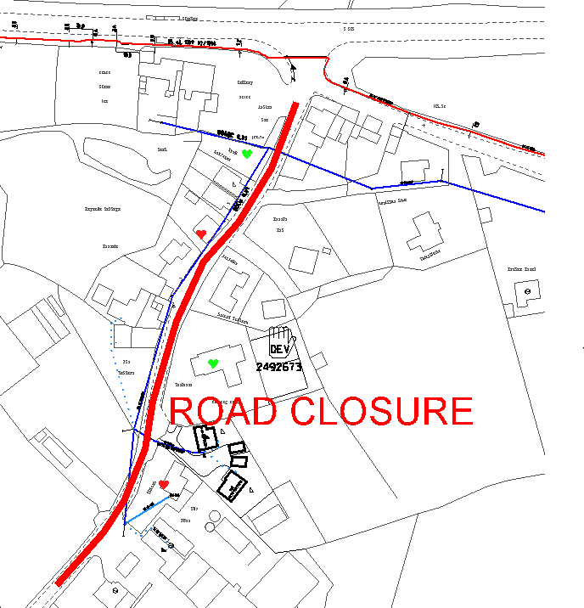
We apologise for any inconvenience this may cause. If you have any queries please do not hesitate to contact me on 01952 601123.
Kind Regards
James Morton

